Car Race Averages

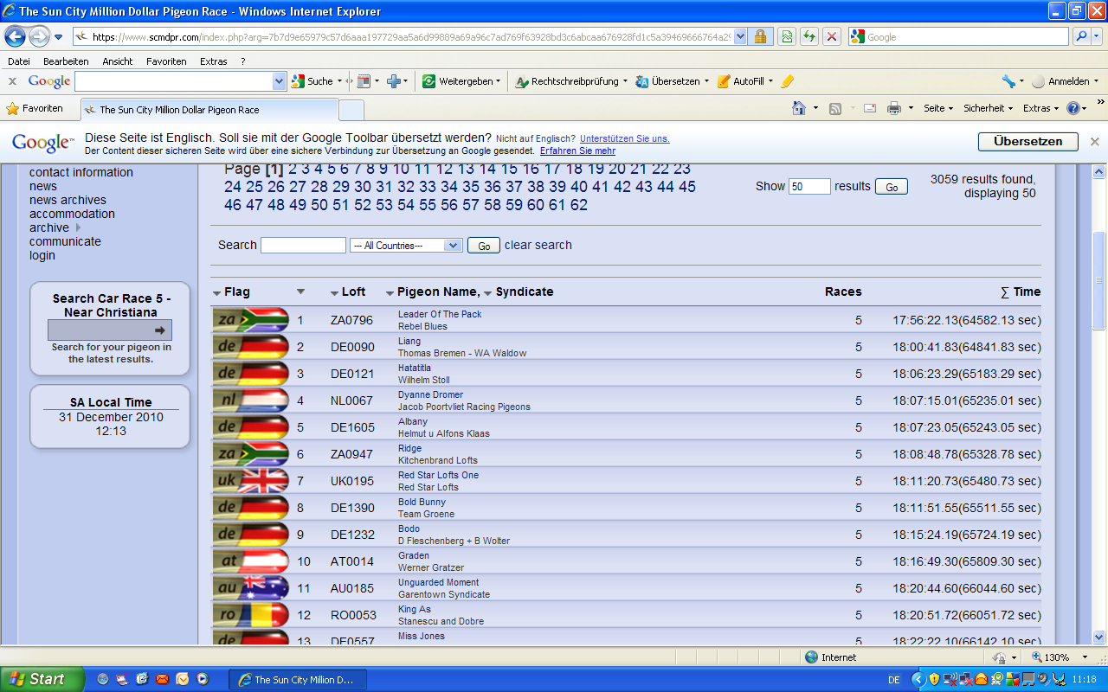
On the 10th place Werner Gratzer with his pigeon Graden.

